**Spine Segmentation in Congenital Scoliosis Based on Level Set Method and Region Growing**

Sunny Patel

Contact: [smp222@njit.edu](mailto:smp222@njit.edu)

**Abstract**

In this paper I am presenting a new technic for segmentation of spine from CT images for patients who have Congenital Scoliosis. In normal cases, segmentation of spine is done by “statistical multi-object shape models”. [1] This technic works fine for normal spine segmentation however it doesn’t if patient has Congenital Scoliosis. “In Congenital scoliosis the spine has deformity which can be caused by a defect present at birth. The spine may also be rotated or twisted, pulling the ribs along with it to form a multidimensional curve.” [2] So, to successfully segment the spine, I am using region growing method with custom seed point. Experimental results show that we can segment spine fairly from CT images.

Keywords: Spine segmentation, region growing, image segmentation

1. **INTRODUCTION**

In medical science, image segmentation or feature extraction plays a major role in diagnosis and treatment of various diseases and fractures. One such case is spine segmentation. The spine segmentation is crucial for examining gray matter and white matter and diseases such as “kyphosis, scoliosis and spondylolisthesis” [3]. There are many effective technics to segment spine from CT (computer tomography) images. One such method is statistical multi object models. This technic is used not only to extract spine but also for joint labelling [1]. It is robust and accurate. However, this model does not work well to segment spine from the CT image of a congenital scoliosis patient because it tries to segment each vertebra from image and scoliosis patient’s vertebras have random deformities. So, I have used region growing method which can effectively segment the spine. In region growing an initial seed point is determined from which for a determined threshold value, we calculate regions which have more contrast than given threshold. This way we can extract the spines which have unusual curvatures.

**2. EXISTING METHOD**

As mentioned earlier, recently statistical multi object shape models is used as it can accurately segment spine from CT images. It can be implemented by various methods. In one method, vertebrae are detected by detecting a common shape of vertebrae in CT image by Generalized Hough Transform [4, 5]. However, this method produces a lot of false positives. In another method, templets of vertebrae are built, and then affine alignment is performed between these templates and detected vertebras [5]. The flow of working of this method is shown in below image [4]. Here, first one is the original image, in second image, spine is detected. Vertebra are marked in the third and last one shows the segmented spine.

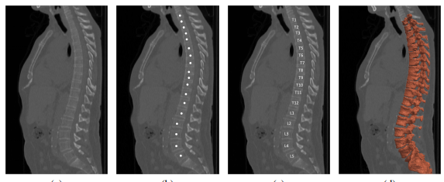

(image reference [4])

Thus, this method works based on training a classifier with common shape of a vertebra

and using it for detecting vertebra in spine and finally segmenting spine according to it.

Though, this method works fine with regular spine which has vertebras and shape which are almost identical to common vertebras used to train classifier, it does not work well if patient has congenital scoliosis. Some CT images of patients who have congenital scoliosis are shown below. From these images it is clear that shape of vertebras can change arbitrarily in multiple dimensions. So, we cannot apply statistical multi object shape models to segment spine in these images.

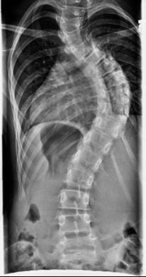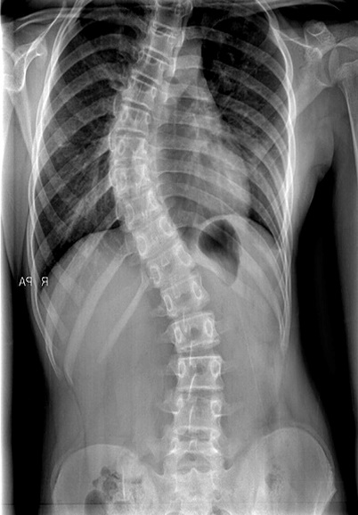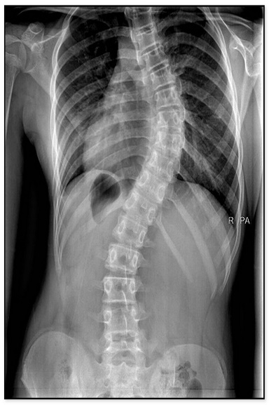

So, we propose a new method based on region growing to segment the spines.

**3. SPINE SEGMENTATION USING REGION GROWING**

To segment the spine using region growing some pre-processing needs to be done.

**3.1 Histogram equalization**

In the first step, input RGB image is converted to gray scale image. This image is likely to have high variance in gray levels because CT images showing bone structures always a dark background. So, in order to enhance the overall contrast of the image we need to perform histogram equalization. Histogram equalization can effectively enhance the contrast of the image however, traditional histogram equalization has a limitation; it can also introduce noise which may become obstacle in region growing. So instead of using traditional histogram equalization, I am using Contrast Limited Adaptive Histogram Equalization (CLAHE) [6]. This method avoids noise by limiting the amplification of contrast.

**3.2 Image smoothing**

To reduce the noise added by histogram equalization, image smoothing is required. I have used Gaussian filter to reduce noise from histogram equalized image. Gaussian filter is a low pass filter which reduces noise in the image by reducing high frequency parts. It also blurs the image. This filter uses a standard deviation to determine the level of smoothing. Since we have used Contrast Limited Adaptive Histogram Equalization, which already produces less noise, we can keep the standard deviation value low. I have chosen to use a gaussian filter with standard deviation 2 for smoothing CT image.

**3.3 Region Growing**

After smoothing the image, region growing can be applied to segment the spine. Region growing is a technic for image segmentation which falls under “pixel classification” category. In this category, pixels are classified according to edge or not an edge category based on some threshold value.

In region growing technic, an initial seed point is decided by user. The original image is displayed to user to select a seed point on it. After that, for every pixel of the image, we check its distance from the initial seed point. If the distance is lesser than the pre-determined threshold, we can say that the pixel belongs to the region and if the pixel has more distance than the threshold value, we discard that pixel. Therefore, this threshold is also known as minimum area threshold. The pixels having distance lesser than the threshold are stored into a new image which is returned as segmented image.

The choice of seed point and threshold plays an important role in segmentation. The ideal choice of seed point is the pixel that has either very high or very low gray scale. If we choose a pixel that has grayscale closer to the average and threshold is very high, many unwanted pixels will be included in the segmented image as their distance from the seed will be likely to be lower than a threshold value. In our case, a seed point with almost highest gray scale and threshold value of 90 is ideal.

**3.4** **Postprocessing**

The segmented image received after applying region growing, may still contain some parts which are not the spine parts. To eliminate them we can convert the image into binary with some threshold. The value of threshold can be deduced from contour plot of the segmented image. After extracting this binary image, we can add it to original image and highlight the parts of spine.

**3.5 Final algorithm:**

The algorithm for proposed method can be summarized as below:

Step – 1: Take the input image and convert it to grayscale if necessary.

Step – 2: Perform Contrast-Limiting Adaptive Histogram Equalization.

Step – 3: Perform image smoothing using Gaussian filter with standard deviation of 2.

Step – 4: Take the input for seed from user. Round of it to nearest integer.

Step – 5: Determine threshold value.

Step – 6: For each pixel of the image, calculate its distance from seed, if the distance is lesser than threshold, include that point into segmented image otherwise discard it.

Step – 7: Plot a contour diagram of the segmented image to decide a threshold for binary image.

Step – 8: Convert the segmented image into binary image and add it into the original image to highlighted regions.

**4. EXPERIMENTAL RESULTS**

I applied this algorithm on following input image. The results of every step are shown.

(image source: [9])

After applying Contrast-Limited Adaptive Histogram Equalization:



After applying Gaussian Filter with standard deviation 2:



Selecting seed point on original image:

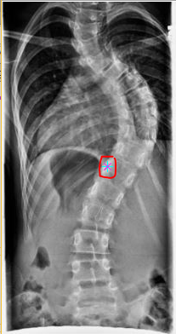

Segmented Spine and its contour plot:

 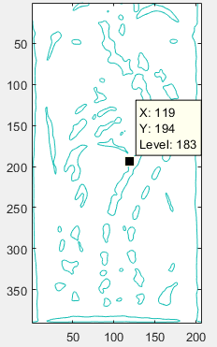

Binary image at threshold = 180 and Final resultant image after adding binary image to original image:

 

Running time of algorithm (according to Matlab profiler): 1.337 second (Seed point was hardcoded to eliminate human interaction time and measure accurate algorithm running time).

Running on other samples (Order: original – segmented – binary - final):

1.

  

2.

   

(image source for all original images: [9])

**5. NEXT STEPS**

The algorithm can be improved by adding some more features. One such feature would be automatically deciding seed point. We are providing seed point manually by selecting on image, however this can be done automatically by creating histogram of image and taking grayscale value near maximum. Similarly, threshold value can also be determined dynamically. It can provide automatic and more accurate results.

Apart from that we can see unwanted areas in binary output results. These regions can be eliminated by applying a classifier trained from dataset of images of vertebras on output binary image.

**6. CONCLUSION**

I have presented a new approach to segment spine from CT images of congenital scoliosis patients. As the region growing method tries to do segmentation based on gray scale levels and does not rely on common shapes of vertebras, it can effectively extract spine whereas current methods cannot do it effectively.

**7. REFERENCES**

[1] A statistical multi-vertebrae shape+pose model for segmentation of CT images. Abtin Rasoulian, [Robert Rohling](http://www.ece.ubc.ca/~rohling/), and [Purang Abolmaesumi](http://www.ece.ubc.ca/~purang/)

[2] [Congenital Scoliosis | Children's Hospital of Philadelphia](http://www.chop.edu/conditions-diseases/congenital-scoliosis). www.chop.edu/conditions-diseases/congenital-scoliosis

[3] Vertebrae segmentation techniques for spinal medical images. [Alaa Atef Darwish](https://ieeexplore.ieee.org/search/searchresult.jsp?searchWithin=%22Authors%22:.QT.Alaa%20Atef%20Darwish.QT.&newsearch=true), [Mohammed A.-M. Salem](https://ieeexplore.ieee.org/search/searchresult.jsp?searchWithin=%22Authors%22:.QT.Mohammed%20A.-M.%20Salem.QT.&newsearch=true), [Doaa Hegazy](https://ieeexplore.ieee.org/search/searchresult.jsp?searchWithin=%22Authors%22:.QT.Doaa%20Hegazy.QT.&newsearch=true), [Hala M. Ebeid](https://ieeexplore.ieee.org/search/searchresult.jsp?searchWithin=%22Authors%22:.QT.Hala%20M.%20Ebeid.QT.&newsearch=true)

[4] Automatic Labeling and Segmentation of Vertebrae in CT Images. [https://pdfs.semanticscholar.org/0875/ac28eea0f0c9795d0710567cc54a5bbb16d1.pd](https://pdfs.semanticscholar.org/0875/ac28eea0f0c9795d0710567cc54a5bbb16d1.pdf)f

[5] Automated model-based vertebra detection, identification, and segmentation in CT images. T. Klinder, J. Ostermann, M. Ehm, A. Franz, R. Kneser, and C. Lorenz. Medical Image Analysis, 13(3):471 – 482, 2009.

[6] Y. Q. Zhao, X. H. Wang, X. F. Wang, F. Y. Shih, “Retinal vessels segmentation based on level set method and region growing,” Pattern Recognition, vol. 47, no. 7, pp. 2437-2446, July 2014.

[7] Andrew Mehnert, Paul Jackway. “An improved seeded region growing algorithm” Pattern Recognition Letters 18 (t997) 1065-1071January 1997.

[8] R. C. Gonzalez and R.E. Woods, Digital Image Processing 2nd Edition, Prentice Hall, New Jersey, 2002

[9] Images: Scoliosis – John Hopkins Medicine.